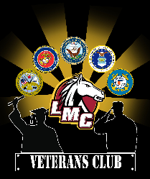
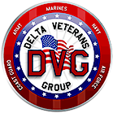
Delta Softball Tournament of Heroes

SAVE THE DATE: May 25-26th 2019

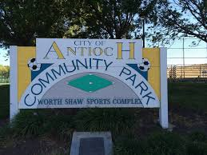
Thank you for all of the life-transforming work you do on behalf of our veterans in the Bay Area. Delta Veterans Group (DVG) and the L.M.C. Veterans Club (LMC VC) are joining forces to host “Delta Softball Tournament of Heroes” May 25-26, 2019 at the Antioch Community Park. This is to raise money for our local veterans community, all money raised goes to help Veterans in the most need and Veterans that are looking to better their transition from Military Service to Civilian Life. DVG is a 501 (c) 3 nonprofit organization in its fifth year of operation (E.I.N. 46-2650624), and is staffed 100% by volunteers who provide services to veterans from all over the Bay Area.

You and your Organization can help DVG and LMC VC with our Mission by your TAX deductible donation and or Sponsorship of the 2019 “Delta Softball Tournament of Heroes”! We are expecting a good turn out at this years Tournament. All money raised goes to Help DVG and LMC VC provide programs to help Veterans in the most need and those veterans making transitional services from active Military to Civilian life.
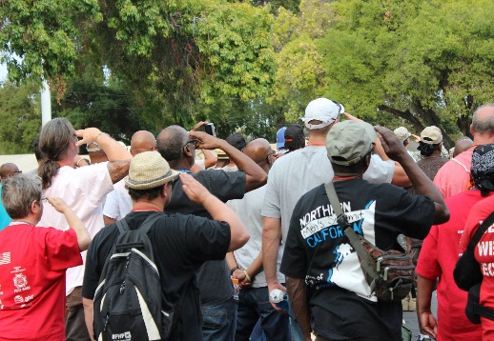
DVG brings Contra Costa County (CCC) “Stand Down on the Delta” a Homeless Veteran’s “Hand Up” event every other year (2015, 2017….) to the CCC Fairgrounds in Antioch, CA. This is a four day event wherein Veteran’s receive services in Medical, Dental, Veterans Treatment Court, Housing, Job Placement, Mental Health and Drug and Alcohol Counseling. To date DVG through our Stand Down on the Delta biennial event has helped over 750 Veterans and their Families, served over 14,000 meals, gave away 600 pairs of boots, 750 sleeping bags, 400 pairs of new Jeans, $40,000 in Dental Care, taken over 70 veterans Fishing on our Delta Shores and helped many more find Permanent Housing. We work with over 70 different organizations during our four day Stand Down on the Delta event. This past August over 1,150 Volunteers from around the State of California came to Antioch to help us provide these great services to our veterans.

As you can see, Delta Veterans Group enjoys wide community support in the East Bay Area of Contra Costa County. DVG Board members include a Past State Commander of a Prominent Veterans Service Organization (VSO), City Council Member, Commanding General of a National Service Organization (USV), Prominent Business Leader’s, Local Commanders of VSO, Disabled Veterans, a Housing Counselor at Independent Living Resources, a staff member of a local nonprofit agency that provides Supportive Services for Veteran Families in Contra Costa, and individuals well connected in the local community.

Sponsorship Levels for the Delta Softball tournament of Heroes:

Four Star General $3,500
(Event Sponsor) Event Sponsor-Product Placement in Prime Locations-Prime Banner Placement-Voice Recognition throughout-4X10 Banner (Your Logo)-Logo on Event Shirt-10X10 Space on Promenade-Full Page in the Tournament Program-8 Event Shirts.
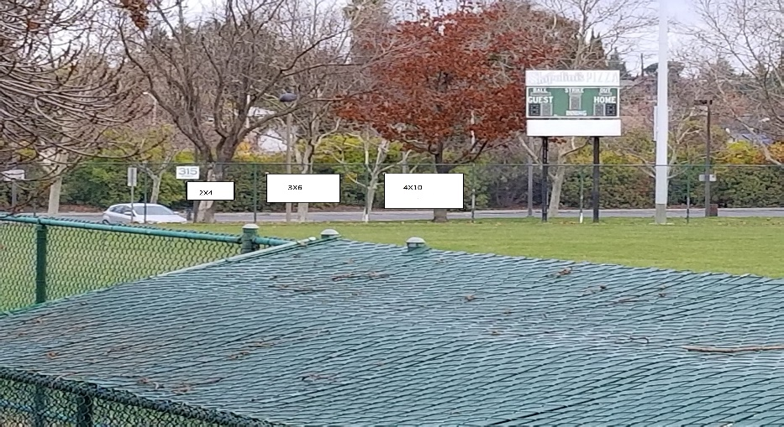
Three Star General $3,000
Voice Recognition-4X10 Banner (Your Logo)-Logo on Event Shirt-10X10 Space on Promenade-1/2 Page in the Tournament Program-8 Event Shirts.
Two Star General $2,500
4X10 Banner (Your Logo)-Logo on Event Shirt-10X10 Space on Promenade-1/2 Page in the Tournament Program -8 Event Shirts.
One Star General $1,500
3X6 Banner (Company Name)-10X10 Space on Promenade- 1/4 Page in the Tournament Program -8 Event Shirts
Command Sergeant Major $1,000
3X6 Banner (Company Name)- 1/4 Page in the Tournament Program -8 Event Shirts.
Sergeant Major $700
2X4 Banner (Company Name) 1/8 Page in the Tournament Program
Sergeant $500
15 person Team Sponsorship-1/8 Page in the Tournament Program
Corporal $300
15 person Team Sponsorship

Thank you for your interest and support for our Veterans. Please Email me at geraldwilson1971@gmail.com if you have any questions, or visit our website at http://www.deltaveteransgroup.org/ to volunteer to assist with the event, or make your financial contribution to help our local Veterans.

Please mail to:
Delta Veterans Group
C/O Delta-softball-tournament-of-heroes
815 Fulton Shipyard Rd
Antioch, CA 94509
